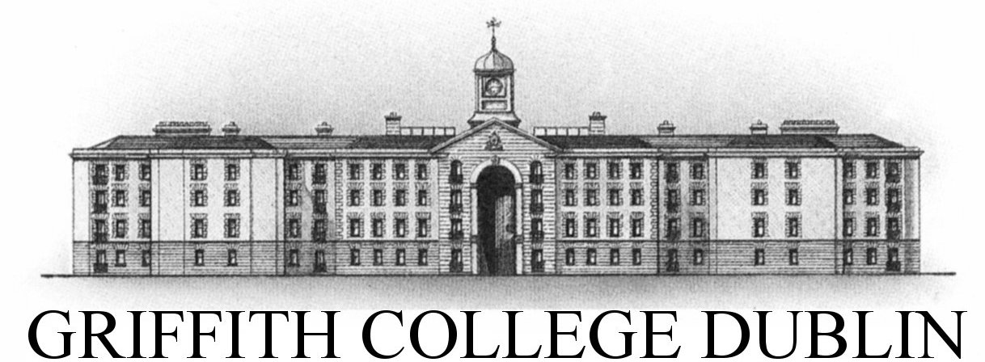

**Assignment Cover Sheet**

|  |  |  |  |  |  |  |
| --- | --- | --- | --- | --- | --- | --- |
| **Student name:** | **Sarah Narayamy Tavares Silva** | | | | | |
| **Student number:** | **2960992** | | |  | | |
| **Faculty:** | **Computing Science** | | |  | | |
| **Course:** | **Computing Science** | | | **Stage/year:** | **3** | |
| **Subject:** | **Networks and Data Communications** | | | | | |
| **Study Mode:** | Full time | **X** |  | Part-time |  |  |
| **Lecturer Name:** | **Brendan Fogarty** | | | | | |
| **Assignment Title:** | **Research Assignment** | | | | | |
| **No. of pages:** |  | | |  | | |
| **Disk included?** | Yes |  |  | No | **X** |  |
| **Additional Information:** | (ie. number of pieces submitted, size of assignment, A2, A3 etc) | | | | | |
|  | | | | | |
|  | | | | | |
| **Date due:** |  | | |  | | |
| **Date submitted:** |  | | |  | | |
|  | | | | | | |
| **Plagiarism disclaimer:**  *I understand that plagiarism is a serious offence and have read and understood the college policy on plagiarism. I also understand that I may receive a mark of zero if I have not identified and properly attributed sources which have been used, referred to, or have in any way influenced the preparation of this assignment, or if I have knowingly allowed others to plagiarise my work in this way.*  *I hereby certify that this assignment is my own work, based on my personal study and/or research, and that I have acknowledged all material and sources used in its preparation. I also certify that the assignment has not previously been submitted for assessment and that I have not copied in part or whole or otherwise plagiarised the work of anyone else, including other students.*  **Signed: Sarah Narayamy Tavares Silva Date: ______________________** | | | | | | |

## **Please note:** Students **MUST** retain a hard / soft copy of **ALL** assignments as well as a receipt issued and signed by a member of Faculty as proof of submission.

TABLE OF CONTENTS

1 INTRODUCTION 2

2 AT&T NETWORK OUTAGE – JANUARY 15TH 1990 3

3 ARIANE 5 FLIGHT 501 – JUNE 4TH 1996 6

4 NOVEMBER 2000 – NATIONAL CANCER INSTITUTE, PANAMA CITY 8

5 CONCLUSION 11

REFERENCES 12

# 1 INTRODUCTION

According to Collins dictionary, Network stands for a system of things which are connected and which operate together. In the computer world, a computer network is a number of computers that connect with each other in order to promote communication of data between users.

There are several

# 2 AT&T NETWORK OUTAGE – JANUARY 15TH 1990

# 3 ARIANE 5 FLIGHT 501 – JUNE 4TH 1996

# 4 NOVEMBER 2000 – NATIONAL CANCER INSTITUTE, PANAMA CITY

# 5 CONCLUSION

# REFERENCES